GIT LAB ASSESSMENT
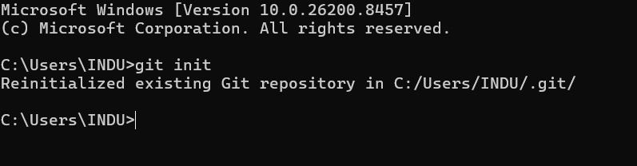
- What is the command to initialize a new Git repository?

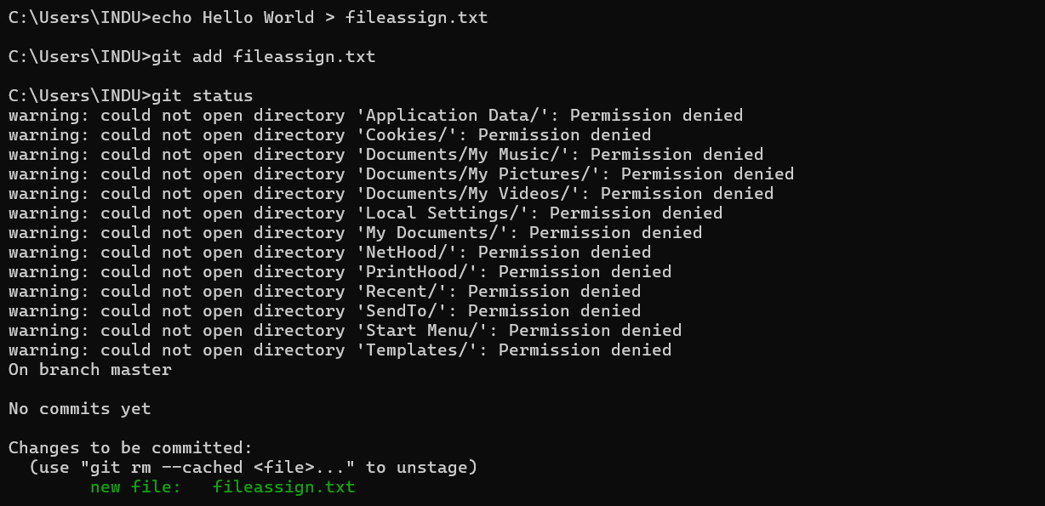
- What is the command to add files to the staging area?

- What is the command to commit changes with a message?

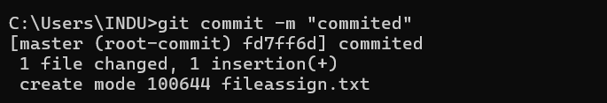

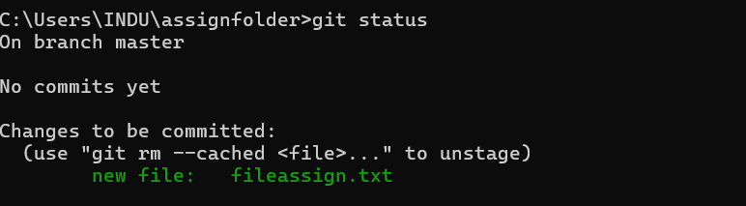
- What is the command to check the status of the repository?
- What is the command to create a new branch and switch to it?

- What is the command to merge a branch into the current branch?
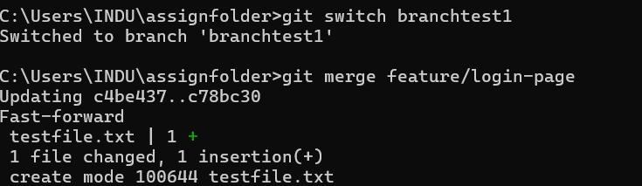

- What is the command to view the differences between two branches or commits?
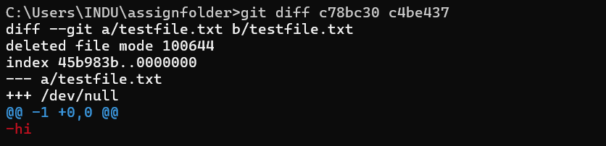

- What is the command to revert changes to a specific file?
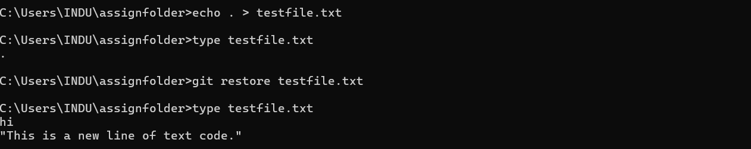

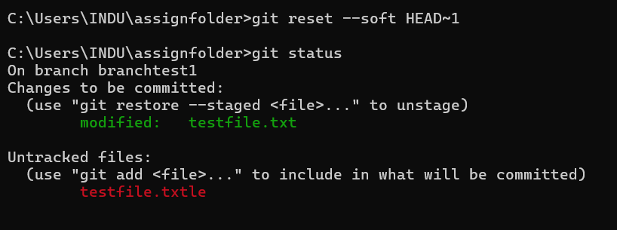
- What is the command to undo the last commit?
10.What is the command to push changes to a remote repository?
